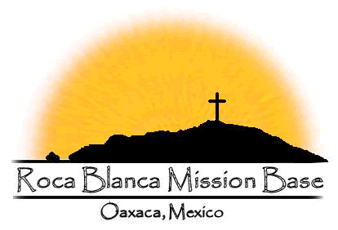

Yes! I want to partner with the Roca Blanca Mission Base!
I want to be an Amigo partner and commit to sending $40/monthly.
Amigo Club partners are those who want to have a closer connection with the ministry at the Roca Blanca Mission Base. They are ones with whom we open our hearts in a special way. With them we share “Amigo stories” telling real-life testimonies of things that have happened to us at Roca Blanca. We will occasionally send them DVDs showing daily life and special events occurring at Roca Blanca. As a partner, you support the operating expenses of the base and help strengthen the ministry in Oaxaca.
Let’s bring the Good News of Jesus Christ to the people of Oaxaca, Mexico.
I will stand with you daily in praying for the Roca Blanca Mission Base.

I want to be an Amigo partner and commit to sending $40/monthly.

I give my support with a one-time gift of $ ________________.

I authorize my monthly gift to be charged to my credit card on the 20th day of each month beginning on ____ / ____ / ____ .

If paying by check, please make payable to: Victory Latin American Outreach
If paying by credit card, please call (620) 662-5400
or mail the completed forms to the address listed below.

Credit Card Type: Mastercard Visa
Credit Card Number:
__ __ __ __ - __ __ __ __ - __ __ __ __ - __ __ __ __
Expiration Date: ______________
______________________________________________
Name (as appears on card)
______________________________________________
Address
______________________________________________
City State Zip
______________________________________________
Email
______________________________________________
Phone Number
______________________________________________
Signature of Cardholder Date

Thanks for your support and please return to:
Victory Latin American Outreach
PO Box 1945
Hutchinson, KS 67504
email: vlao3@sbcglobal.net
Tel: (620) 662-5400

